A
Text Structure Quiz

Direction: read each passage and identify how the information is being organized.

1. b.
2. d.
3. a.
4. c.
5. e.
6. e.
7. c.
8. d.
9. b.
Matching: match the definition to the term and shade in the appropriate bubble.

10. An action and its results are discussed D  11. Information is organized in order of time A  12. a difficulty is described and an answer is offered B | a. chronological  b. problem and solution  c. sequence / process  d. cause and effect

13. Differences and similarities of two or more things are discussed C  14. Explains how something happens or is done, step-by-step D  15. Describes how something looks or the arrangement of a space B | a. cause and effect  b. spatial / descriptive  c. compare and contrast  d. sequence / process

Name:___________________________
Date:____________________________
Period:___________________________

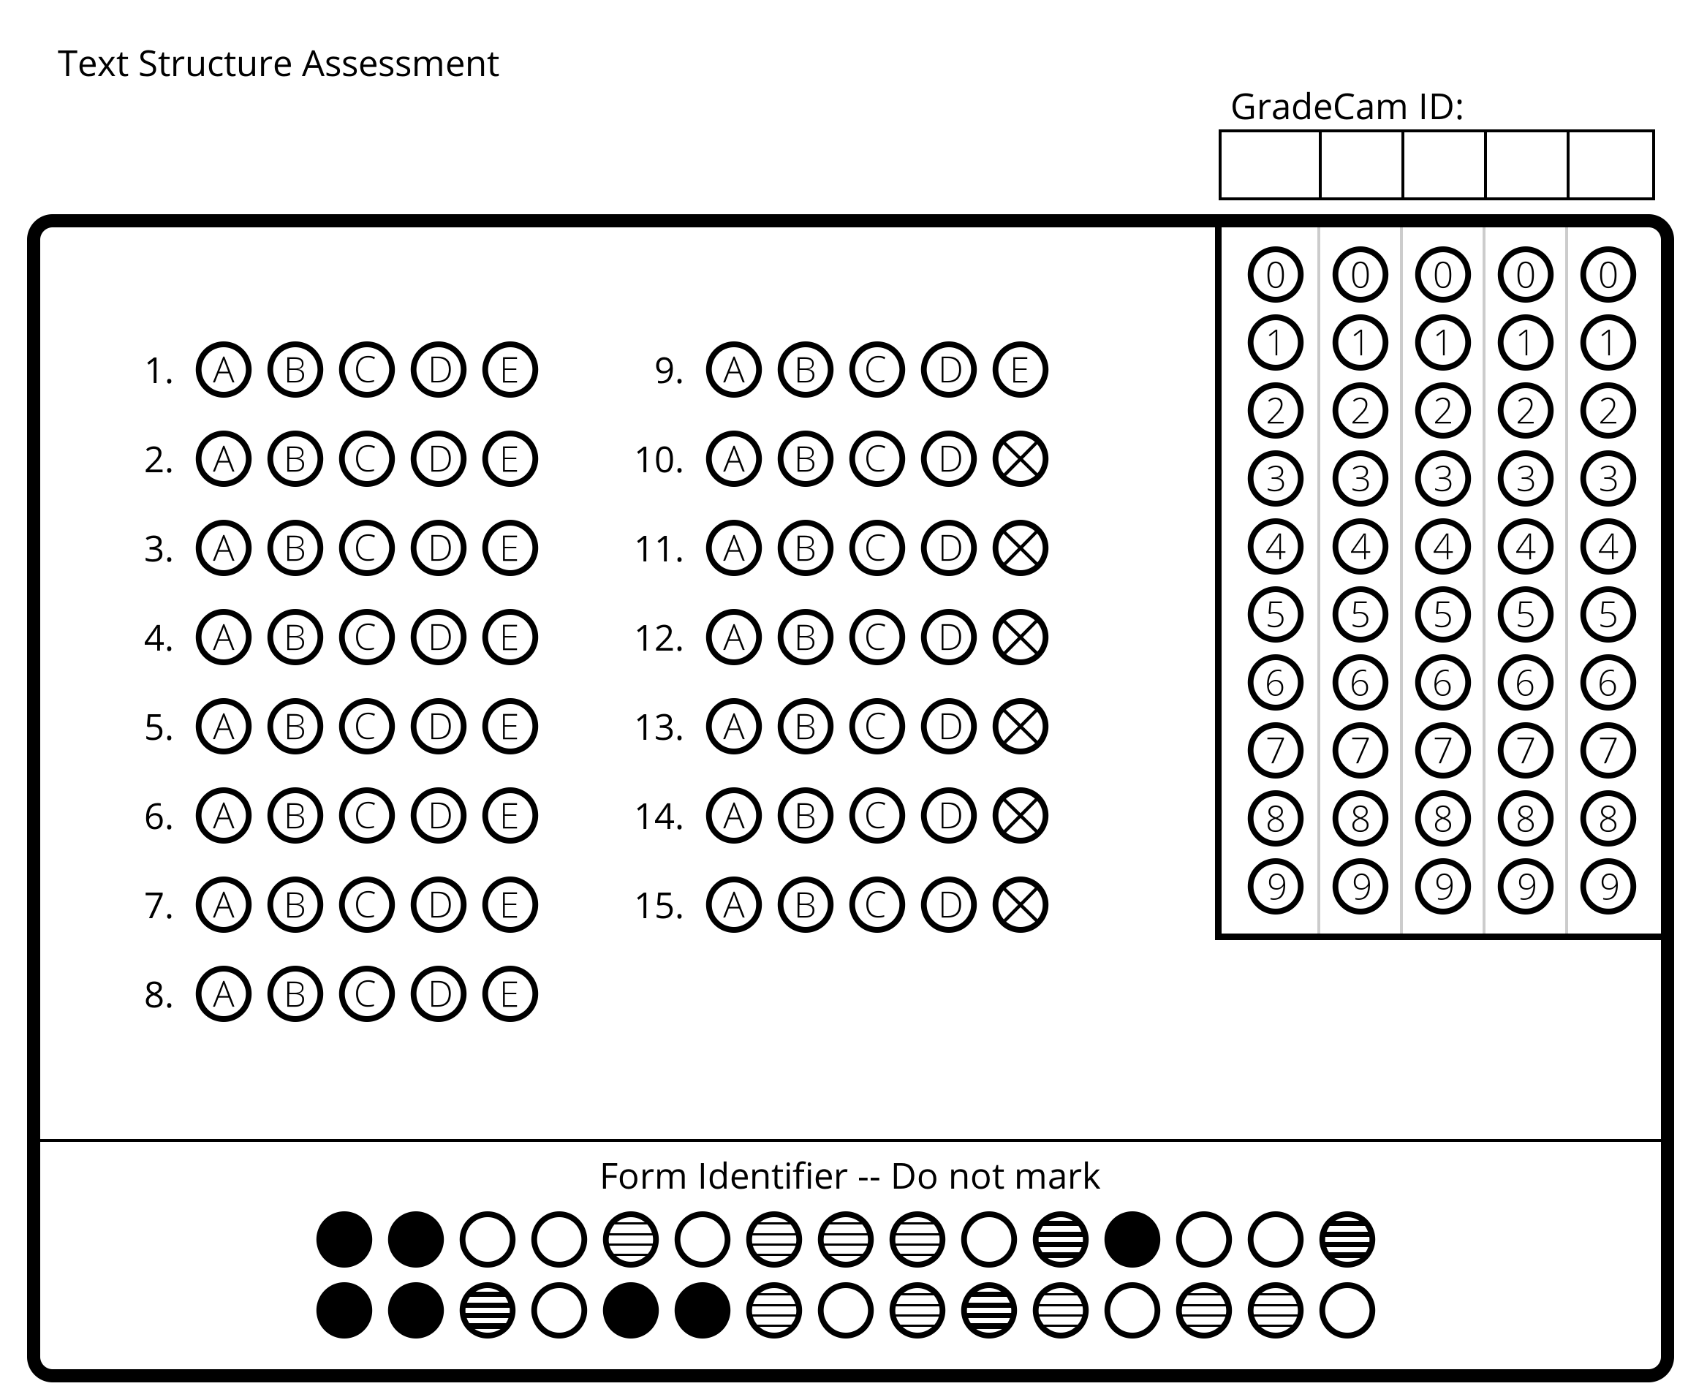

Name:___________________________
Date:____________________________
Period:___________________________

B
Text Structure Quiz

Direction: read each passage and identify how the information is being organized.

- e
- a.
- e.
- e.
- c.
- c.
- a.
- b.
- d.

Matching: match the definition to the term and shade in the appropriate bubble.

10. An action and its results are discussed D  11. Information is organized in order of time A  12. a difficulty is described and an answer is offered B | a. chronological  b. problem and solution  c. sequence / process  d. cause and effect

13. Differences and similarities of two or more things are discussed C  14. Explains how something happens or is done, step-by-step D  15. Describes how something looks or the arrangement of a space B | a. cause and effect  b. spatial / descriptive  c. compare and contrast  d. sequence / process

Name:___________________________
Date:____________________________
Period:___________________________

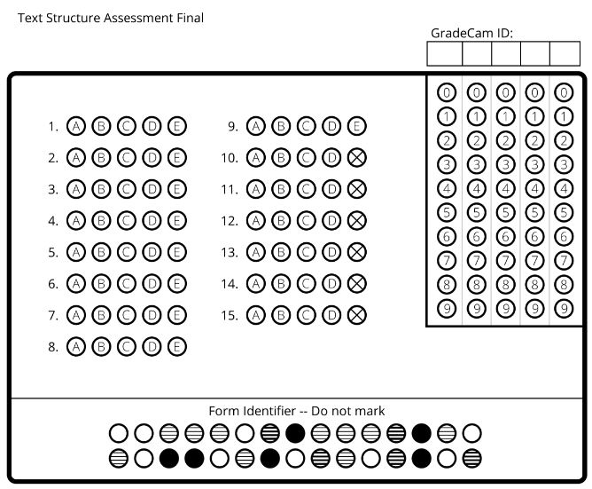

Name:___________________________
Date:____________________________
Period:___________________________

